Manycore | SpatialVerse

2025 NVIDIA GTC Giveaway List
- Customized Pen
- Quantity: 200 (100 for each design)
- Size: 14cm*1cm
- Designs:

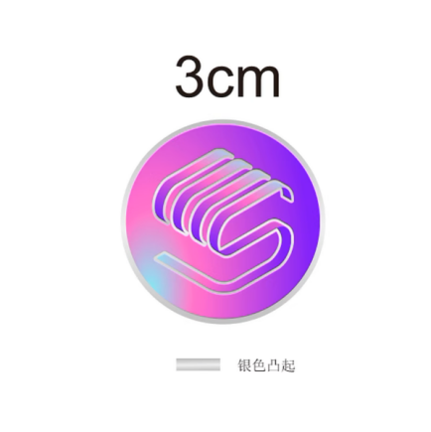
- Customized Pin
- Quantity: 200
- Size: 3cm*3cm
- Design:

- Customized paper bag
- Quantity: 200
- Size: 26cm*36cm*8cm
- Design:

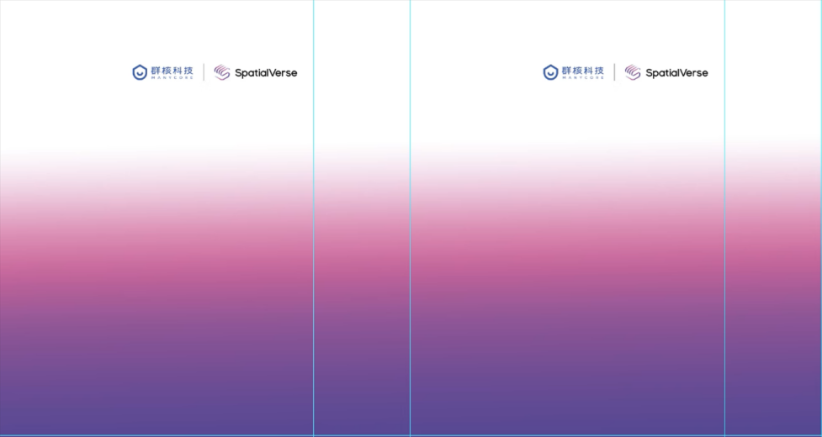

- Customized t-shirt
- Quantity: 20 (10 for each size)
- Size: medium (170cm height) and large (185cm height)
- Design:
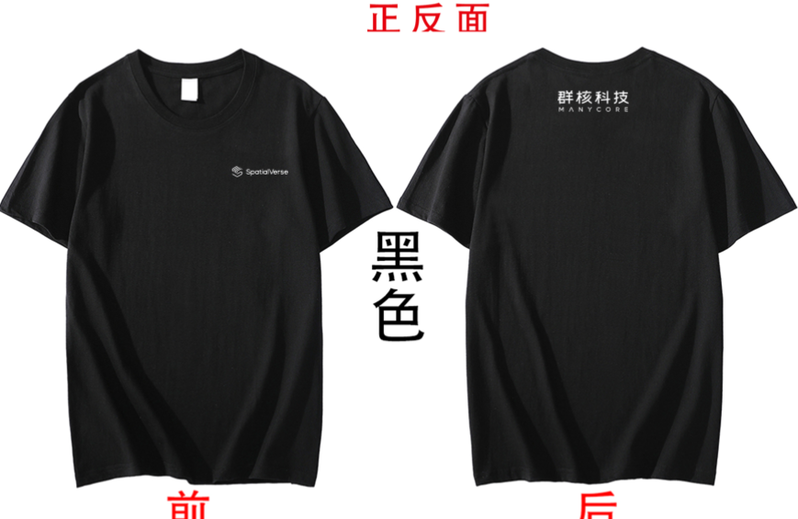
- Building Bricks Package
- Quantity：40 (~120pcs in each package)
- Size: 18cm*28cm*3cm
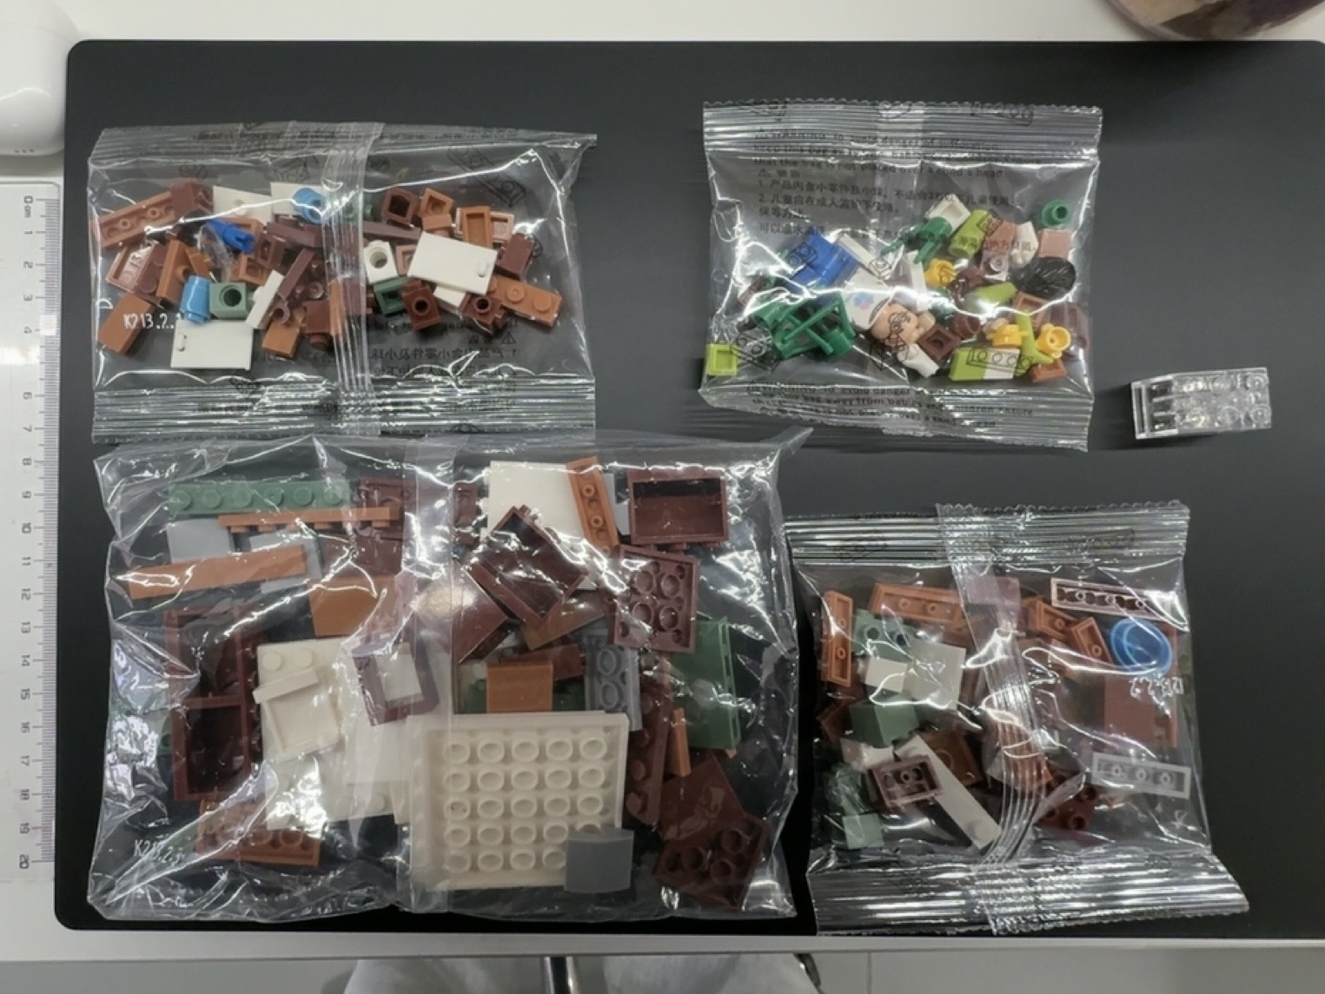
- Design:

